一种适用于循环式电器检测仪的自动识别和校验系统

李云鹏1 姜娇龙1 单威强1

（1.上汽大众）

【摘要】本文介绍了一种适用于循环式电器检测仪的自动识别车辆生产号并校验车辆VIN(Vehicle Identification Number) 识别号的系统，主要应用于汽车制造工厂流水线中需要跟车随行且需要获取车辆订单信息的制造场景。特别对于无纸化工厂，由于取消了纸质流程卡，工人无法通过人工扫描流程卡上的条码快速获得车辆订单信息，因此本文所述的这种自动识别和校验系统成为了无纸化工厂所必需。本系统采用RFID(Radio Frequency Identification)读头和FIRAP(Fast Infra Access Point)快速红外收发器配合电器检测仪工作，来实现车辆生产信息的自动获取和传递，并通过软件防错和下段工位自动校验等手段，达到了非常好的实际应用效果。本文解决了无纸化工厂的循环式电器检测仪自动识别车辆生产信息的问题；节约单车人工工时约8s，不存在人机工程抱怨问题；具有校验功能，信息的准确性更高，降低返工成本；并可以推广到其他有类似应用场景的工厂。

【关键词】自动识别；红外收发器；防错校验；无纸化工厂；

**A set of automatic identification and verification facility to cyclic E-check Tester**

LI YUNPENG JIANG JIAOLONG SHAN WEIQIANG

SAIC VOLKSWAGAN CO, LTD

**Abstract**：This paper introduces an automatic facility used for automatic identification and verification of vehicle VIN (vehicle identification number) of E-check tester, which is mainly used in the manufacturing scene where the car needs to be accompanied and the vehicle information needs to be obtained in the production line. Because paperless plants cancel the paper process card, it is impossible to obtain vehicle information by manually scanning the process card. Therefore, the algorithm fusion of RFID (radio frequency identification) reader and FIRAP(fast infra access point) transceiver is used to realize the automatic acquisition, information transmission and error proofing of vehicle ID information, which achieves very good practical effect. This paper solves the problem of identifying vehicle information by cycle detector in Paperless plant; At the same time, it can save about 8s production time and reduce the cost of single vehicle; With verification function, the accuracy of information is higher and the rework cost is reduced; And it can be extended to other car plants with similar application scenarios.

**Key words**：Automatic recognition; Fast Infra Access Point; Error proofing; Paperless plant;

0 **引言**

随着汽车产业不断发展和工业4.0的推动，制造执行系统（MES）在越来越多的传统制造企业中得到利用，作业管理工艺规程自动化正随着数字化设计和制造水平的提升，将设计和工艺数据流应用于现场生产，在离散型车间实现无纸化工艺得到越来越多的关注。

With the continuous development of the automobile industry and the promotion of Industry 4.0, the manufacturing execution system (MES) is being used in more and more traditional manufacturing enterprises. The automation of operation management process and procedures is increasing with the improvement of digital design and manufacturing. Process data flow is used in on-site production, and the realization of paperless processes in discrete workshops has received more and more attention.

增加无纸化功能来实现生产文档的自动高效传递和管理，采用大屏显示对生产信息的可视化进行有效展示和监控，配置可触摸显示终端配以解决可视化问题。这样大大提高了工作效率，降低了成本，进一步提升了生产现场管理水平。然而无纸化功能也将给流水线生产带来难题，比如取消了流程卡则使得车辆信息难以获得，为此需要车间管理人员提前规划、提前布局，解决问题，进一步提高生产自动化率。

The paperless function is added to realize the automatic and efficient transmission and management of production documents, the large-screen display is used to effectively display and monitor the visualization of production information, and the touch display terminal is configured to solve the visualization problem. This greatly improves work efficiency, reduces costs, and further improves the level of production site management. However, paperless functions will also bring difficulties to assembly line. For example, the cancellation of process cards makes it difficult to obtain vehicle information. For this reason, it is necessary for workshop managers to plan in advance, lay out in advance, solve problems, and further improve the production automation rate.

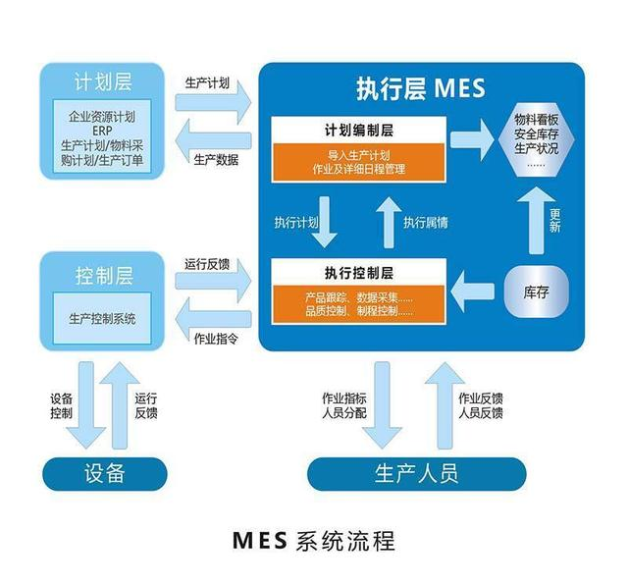

图1 无纸化工厂示意图

Figure1 paperless plant sketch map

1 需求分析

目前，在整车流水线使用循环式的电器检测仪用于汽车的控制器诊断、刷新等操作。为获取车辆信息，工人需要将检测仪取下扫描随车装配单上的VIN条形码，然后放回随行机构与车辆随行。这种方法有三个弊端：一是随着工厂信息化进一步提高，目前都逐渐推广无纸化工厂，装配单会被取消，工人将无法扫描装配单；二是扫描流程卡需要大约8s，会增加单车成本。三是缺少校验，一旦发生工人错误扫描或者识别错误，会造成车辆无法发动，需要额外的返工成本。

At present, a circulating electrical tester is used in the vehicle assembly line for the diagnosis and flash of the car's controllers. In order to obtain vehicle information, workers need to take the tester and scan the VIN barcode on the vehicle assembly sheet, and then return it to the moving unit which follows the vehicle in the assembly line. This method has three drawbacks: First, with the further improvement of factory digitalization, paperless factories are gradually being promoted, assembly sheet will be cancelled, and workers will not be able to scan assembly sheet; second, it takes about 8s to scan the assembly sheet, which will increase cost per car. The third is the lack of verification. Once workers scan or identify the wrong vehicle, the vehicle will not be able to start, and additional rework costs will be required.

如下为一个基本检测区的工作流程图。一个工厂有多个检测区。

The following is a working flow chart of a basic diagnostic area. A factory has multiple diagnostic areas.

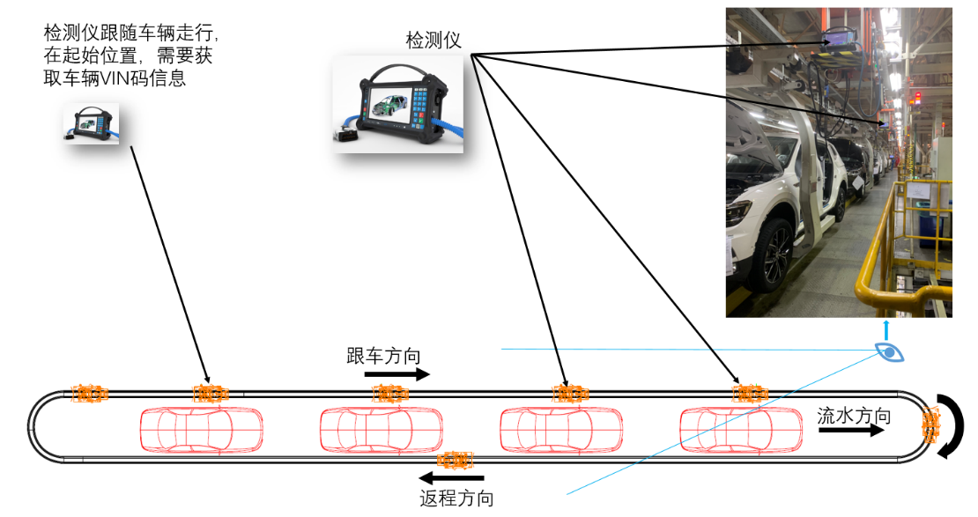

图2 循环式电器检测仪流向示意图

Figure2 cyclic E-check tester in production line sketch map

1. 系统结构简介

为了解决这一难题，本文设计了一种电器检测仪自动获取、校验车辆生产信息的系统。该系统由RFID标签、RFID（Radio Frequency Identification）读头、FIRAP（Fast Infra Access Point）快速红外收发器、车辆订单服务器、电器检测仪等部件组成。他们彼此配合无间，并辅以软件防错和自动校验功能，可以确保车辆自动识别和校验，避免缺陷发现太晚。

In order to solve this problem, this paper designs a system for automatic acquisition and verification of vehicle production information by E-tester. The system consists of RFID tags, RFID (Radio Frequency Identification) readers, FIRAP (Fast Infra Access Point), vehicle order servers, electrical testers and other components. They cooperate seamlessly with each other, supplemented by software error prevention and automatic verification functions, which can ensure that the vehicle is automatically identified and verified to prevent defects from being discovered too late.

**2.1 系统工作原理**

结构形式为，在车顶上方钢结构处安装一个固定式的RFID读头，读取该车辆车顶上RFID标签里的PIN（Production Identification Number）码即车辆生产信息码，该维码被用于订单管理，与车辆VIN码有一一对应关系。在电器检测仪起始工位上方安装一个固定式的FIRAP快速红外收发器。当RFID读头识别出车辆PIN码后，立即将PIN码通过局域网传递给FIRAP快速红外收发器。快速红外收发器收到当前车辆PIN码后将进行有限区域的广播，该广播区域可以设置。当电器检测仪进入该红外收发器广播范围后，红外收发器将当前的PIN码传递给当前的检测仪。电器检测仪收到当前车辆PIN码后将开始跟车随行，并将PIN码发送到生产信息管理系统，请求得到该车辆的VIN码。电器检测仪在得到VIN码后， 随即将该VIN信息写入到车辆网关控制器中，然后顺序执行该工位安排的控制器刷写、配置等电检工作。

The structure is as follows: a fixed RFID reader is installed on the steel structure above the roof to read the PIN (Production Identification Number) code in the RFID tag on the roof of the vehicle, which is the vehicle production information code. The code is used In order management, there is a one-to-one correspondence with the vehicle VIN code. Install a fixed FIRAP above the starting station of the electrical tester. When the RFID reader recognizes the PIN code of the vehicle, it immediately transmits the PIN code to the FIRAP via the local area network. After the fast infrared transceiver receives the current vehicle PIN code, it will broadcast in a limited area, and the broadcast area can be set. When the electrical tester enters the broadcasting range of the infrared transceiver, the infrared transceiver transmits the current PIN code to the current tester. After receiving the current vehicle PIN code, the electrical tester will start to follow the car and send the PIN code to the production information management system to request the VIN code of the vehicle. After the electrical tester obtains the VIN code, it immediately writes the VIN information into the vehicle gateway controller, and then sequentially executes the electrical diagnostic tasks such as controller flash and configuration arranged by the station.

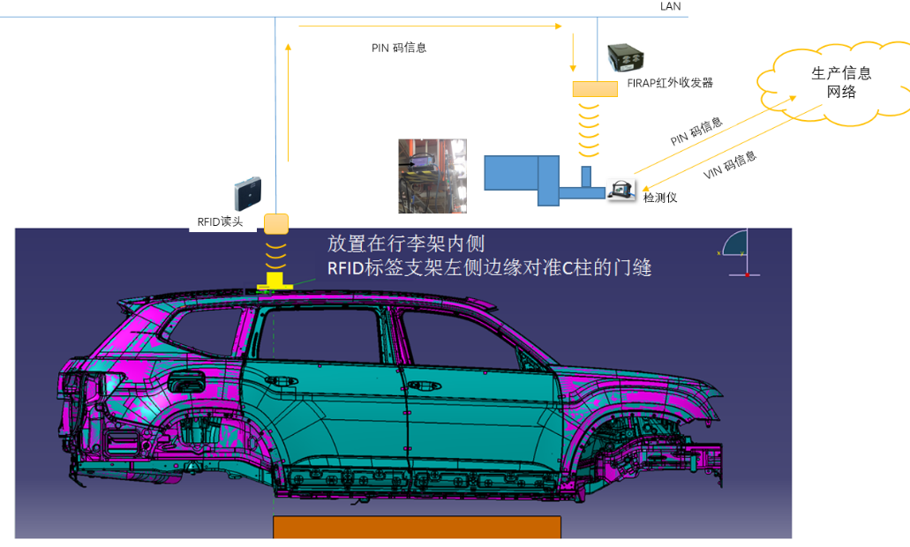

图3 系统结构示意图

Figure3 facility structure map

**2.2 校验方案**

从车辆从白车身进总装车间到最终下线，需要经过多个电器检测区。车辆的网关控制器在第一个电检区写入了VIN号后，当其流转到下一个检测区时，可以对车辆VIN号信息进行校验。该检测区安装完全相同的RFID读头和红外收发器，通过检测区RFID读头获取到RFID标签信息并传递给快速红外收发器并最终推送给电器检测仪。电器检测仪则根据PIN码从订单服务器里检索出VIN号，与上一段电检工位里已经写入到网关控制器里的VIN码进行比对、校验。如比对合格，则说明车辆识别无误；若不合格，检测仪弹出报红界面，提示工人VIN码错误需要排查故障原因，避免缺陷继续往下流。为了确保VIN信息识别的准确性，通过两个途径进行保证：一是RFID读取信息后即刻发送，不会存储，信息的传递是即时的，不存在存储时间，保证信息不会错乱，红外收发器收到RFID信息，在发送给检测仪后也是立即删除，保证不会重复误发送；二是通过下一段工位进行读取比对来校验，核对，确保两次的识别都是一致的、可靠的、准确的。通过生产实践证明，校验结果证明99.9%的车辆都是正确的，可以顺利下线。0.1%的车辆由于现场的其他突发因素或人工干扰而导致读取失败，而需要进行车辆返工电检。

From the vehicle entering the assembly shop to the end of line, it needs to pass through multiple electrical testing areas. After the vehicle's gateway controller writes the VIN number in the first electrical testing area, when it flows to the next testing area, it can verify the vehicle's VIN number information. The verification area is equipped with exactly the same RFID reading head and infrared transceiver. The RFID tag information is obtained through the RFID reading head in the verification area and passed to the fast infrared transceiver and finally being written to the electrical tester. The electrical tester retrieves the VIN number from the order server according to the PIN code, and compares and verifies it with the VIN code written into the gateway controller in the previous section of the electrical testing station. If the VIN is the same, it means that the vehicle identification is correct; if it is not the same, the tester pops up a red interface, prompting the worker that the VIN code is wrong and the cause of the fault needs to be investigated to prevent the defect from continuing to flow down. In order to ensure the accuracy of VIN information identification, it is guaranteed by two methods: one is to send the information immediately after RFID reads it, and it will not be stored. The transmission of the information is instant, there is no storage time to ensure that the information will not be confused. After receiving the RFID information, the device will delete it immediately after sending it to the tester to ensure that it will not be repeatedly sent by mistake; the second is to verify through the next stage, to ensure that the two identifications are consistent, reliable and accurate. Proved by production practice, the verification result proves that 99.9% of the vehicles are correct. 0.1% of the vehicles are failed to read due to other unexpected factors or manual interference on site, for those vehicles , electrical rework are required.

**2.3 防错机制**

由于红外收发器广播有一定的范围，在其影响范围内的电器检测仪都有可能获得它发出的PIN号信息。当然这个范围也可以根据实际生产过程进行进一步优化，但再怎么调也并不能从根本上杜绝多个检测仪获取PIN号信息的现象。为了尽可能保证一台检测设备获取到的有效PIN号只有一个，从检测仪的软件上进行防错处理。一是上述所说的红外收发器收到RFID信息，在发送给检测仪后立即删除，然后等待识别下一台车的RFID标签。二是当检测仪获取到PIN号即进入该工位电检流程中，等待车辆上电信号，若车辆很快上电，则自动执行电检工作；若超过一定时间比如60JPH的流水线工厂设置等待时间为50s，还没有上电信号，则测试界面跳出到提示工人输入PIN码界面，此时工人需要扫码或者手动输入PIN号，否则这台车无法做电检。

Since the infrared transceiver has a certain range for broadcasting, E-testers within its influence range may obtain the PIN number information it sends. Of course, this range can be further optimized according to the actual production process, but no matter how it is adjusted, it will not fundamentally eliminate the phenomenon that multiple testers obtain PIN number information. In order to ensure that there is only one valid PIN number obtained by a testing device, error prevention is performed on the software of the testing instrument. One is that the aforementioned infrared transceiver receives the RFID information, deletes it immediately after sending it to the tester, and then waits for the RFID tag of the next vehicle to be identified. Second, when the tester obtains the PIN number, it enters the electric inspection process of the station and waits for the vehicle's power-on signal. If the vehicle is powered on soon, it will automatically perform the electric inspection work; if it exceeds a certain time, such as 60JPH assembly line factory settings, 50s, and there is no power-on signal, the test interface will pop up to the interface that prompts the worker to enter the PIN code. At this time, the worker needs to scan the code or manually enter the PIN number, otherwise the car cannot be tested.

* 1. **结果验证**

经过大批量生产实践的验证，本系统可以很好地实现车辆VIN号信息自动识别、自动写入和校验，有利于提高自动化率和生产节拍。整套系统工作过程是稳定的、可靠的、有效的，也是车辆电检自动化和无纸化所必需具备的一套系统。

After the mass production practice, this system can well realize the automatic identification, automatic writing and verification of vehicle VIN number information, which is beneficial to improve the automation rate and production cycle. The working process of the whole system is stable, reliable and effective. It is also a set of systems necessary for the automation and paperlessness of vehicle electrical inspection.

3 结论

本文针对无纸化工厂带来的车辆生产信息识别难题，给出了一整套解决方案。成功地解决无纸化工厂的循环式电检检测仪如何自动识别车辆信息的问题，节约了人工工时，降低单车成本；具有自动校验功能，可实现车辆信息获取的高度准确性，带来的返工成本更低；同时可以应用于其它类似场景的工厂中，具有广泛的推广价值。

This article provides a set of solutions to the problem of vehicle production information identification brought by paperless plants. Successfully solved the problem of automatically identifying the vehicle information,by E-testers, which saves man-hours and reduces the cost of a single vehicle; it has an automatic verification function that can achieve a high degree of accuracy in vehicle information acquisition. Rework costs are lower. At the same time, it can be applied to other factories in similar scenarios, which has a wide range of promotion value.

【参考文献】（References）（中文宋体小五号，英文Times New Roman10号）

如需中英文对照，写法如下：

[1] 曹雪菲，寇卫东，党岚君，等. 基于身份公钥的后三代UMTS安全漫游方案[J]. 中国科技论文在线，2008，3(1)：1～5.

CAO X F, KOU W D, DANG L J, et al. B3G UMTS secure roaming scheme based on ID-based cryptography[J]. Sciencepaper online，2008, 3(1): 1～5. (in Chinese)

[2] „„